PRESTASHOP
INDEX:

- Exercise 1: Install Prestashop without any data. Change the name of the
shop and use (Your name's online Shop). Create a full screen snapshot Pag 3
(look for the right browser extension for that).
- Exercise 2: Write down the required Apache version, Php version
and MySQL for your Prestashop Installation. Pag 4
- Exercise 3: Change the home page:
  - Change the website logo. Pag 5
  - Desactivate any modules you need in order to show only
contact info and categories at the footpage Pag 6
  - Change the contact module and use IES Triana address
as the shop address.
  - Describe the process for all the previous changes and add a full
screen snapshot similar to the following picture. Pag 7-8
- Exercise 4:Create 3 categories (Dcoumentation / Software
/ Solutions ). Change the configuration of the horizontal menu
ir oder to show those 3 categories and as a not logged user create
a full screen snapshopt similar to the following picture. Pag 9-11
- Exercise 5: Add three products for each of one the new categories
and as a not logged user create a full screen snapshopt similar to the
following picture (New Producs or What's new section). Pag 12-14
- Exercise 6: Configure and Install (if needed) the Home Slide module
to show the new and previously added products. Explain the process
and as a not logged user create a full screen snapshopt similar to
the following picture. Pag 15-16
- Exercise 7: Create a backUp of your app's database.
firstname_lastname_prestashop.sql. Pag 17
- Exercise 8: Look for 10 things to secure Prestashop
after installation. Pag 17
Exercise 1: Install Prestashop without any data. Change the name of the shop and use (Your name's online Shop). Create a full screen snapshot (look for the right browser extension for that).

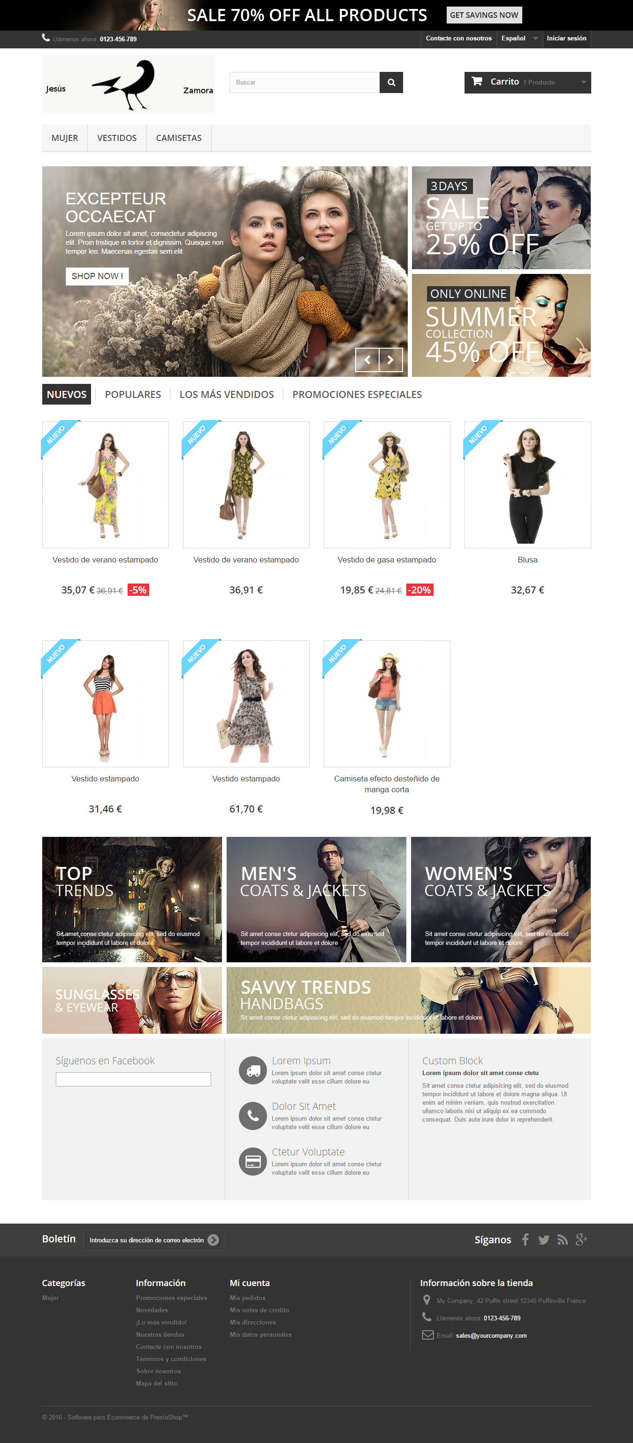

Exercise 2: Write down the required Apache version, Php version and MySQL for your Prestashop Installation.
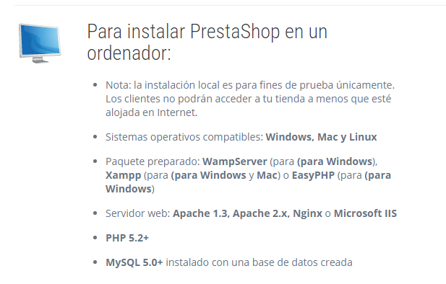

Exercise 3: Change the home page:
  - Change the website logo.

  - Desactivate any modules you need in order to show only contact info and categories at the footpage.
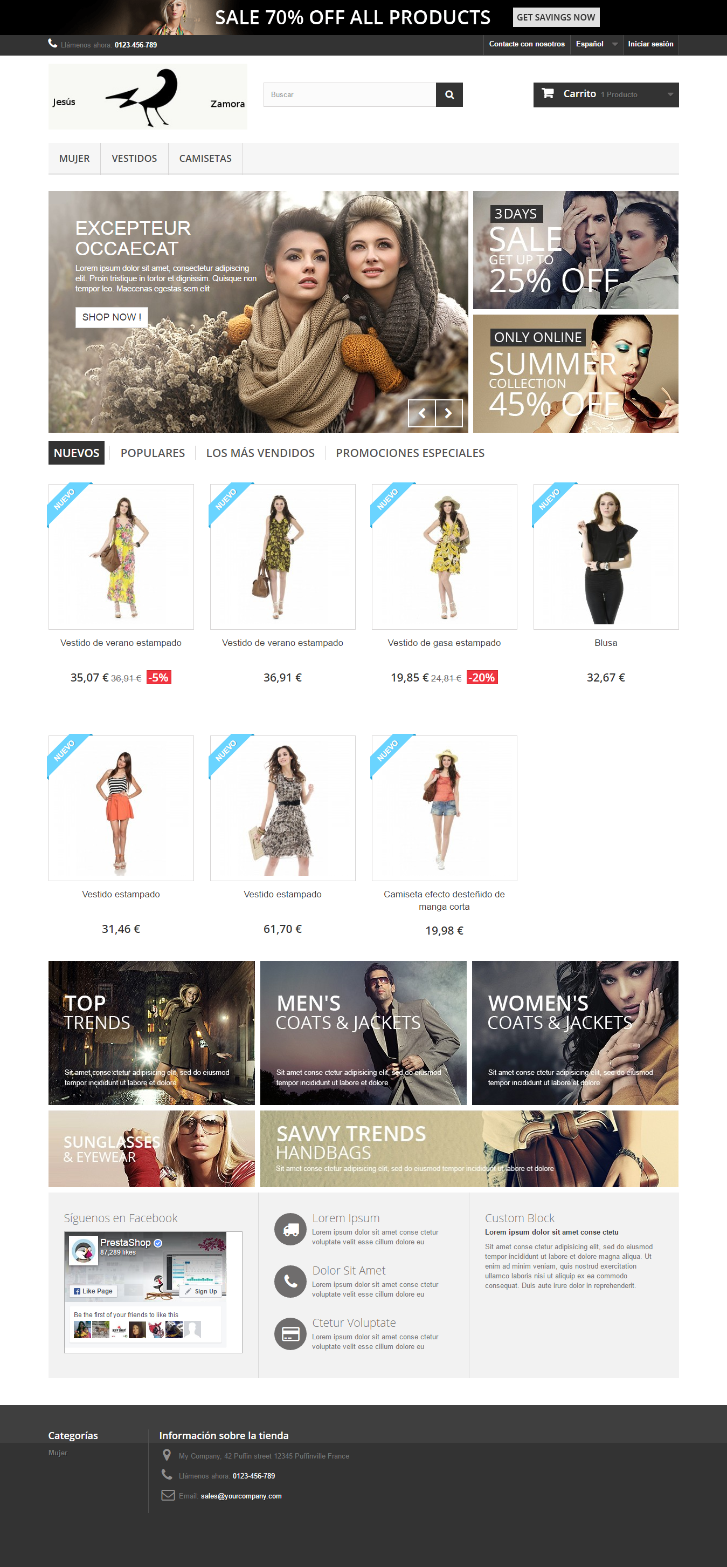

  - Describe the process for all the previous changes and add a full screen snapshot similar to the following picture.
    - To change the logo I must go to Preferences > Themes and go to logo tab.
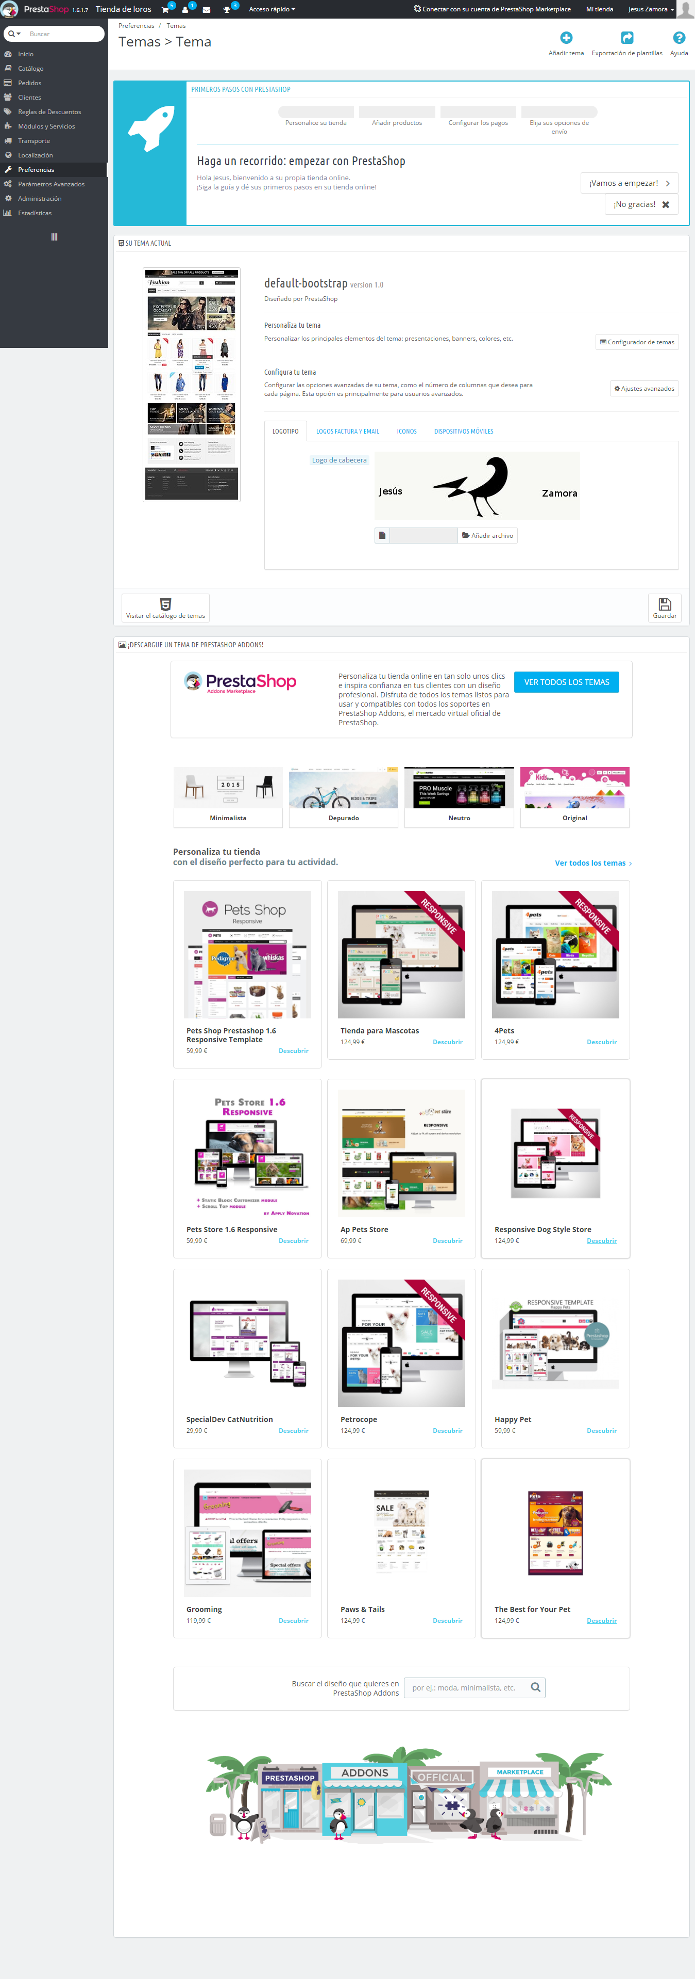

    - To show only contact info and categories at the footpage I go to Positions modules > Modules and Services, and and filter by foot. I just leave selected those required in this point of the exercise.
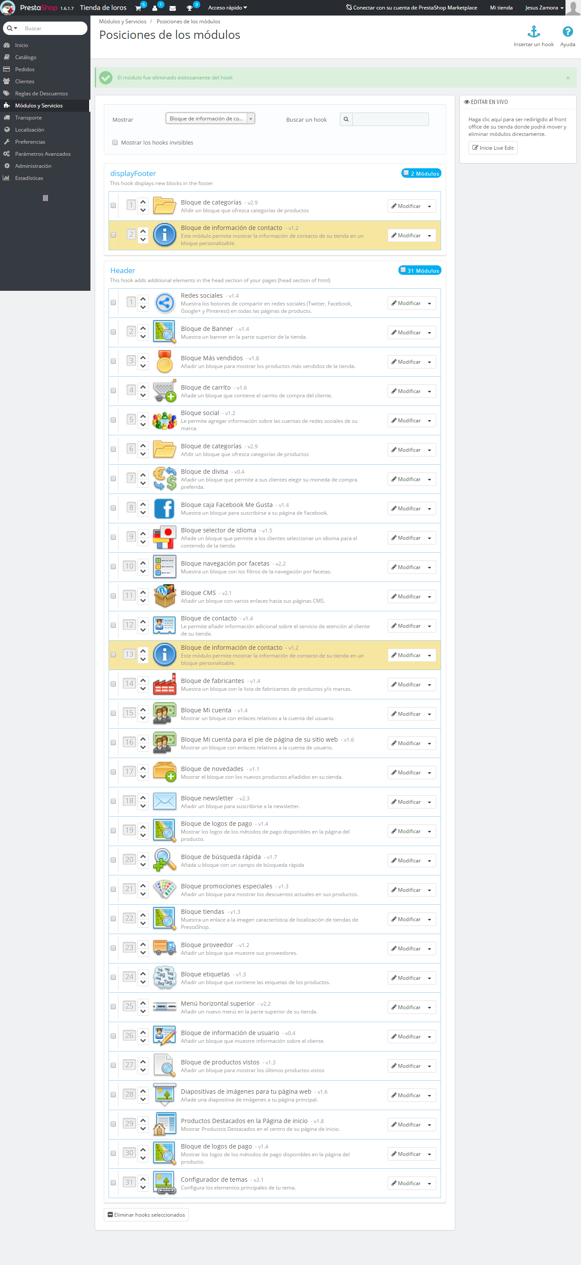

Exercise 4: Create 3 categories (Dcoumentation / Software / Solutions ). Change the configuration of the horizontal menu ir oder to show those 3 categories and as a not logged user create a full screen snapshopt similar to the following picture.

From categories, I add three new categories, called as called practice:
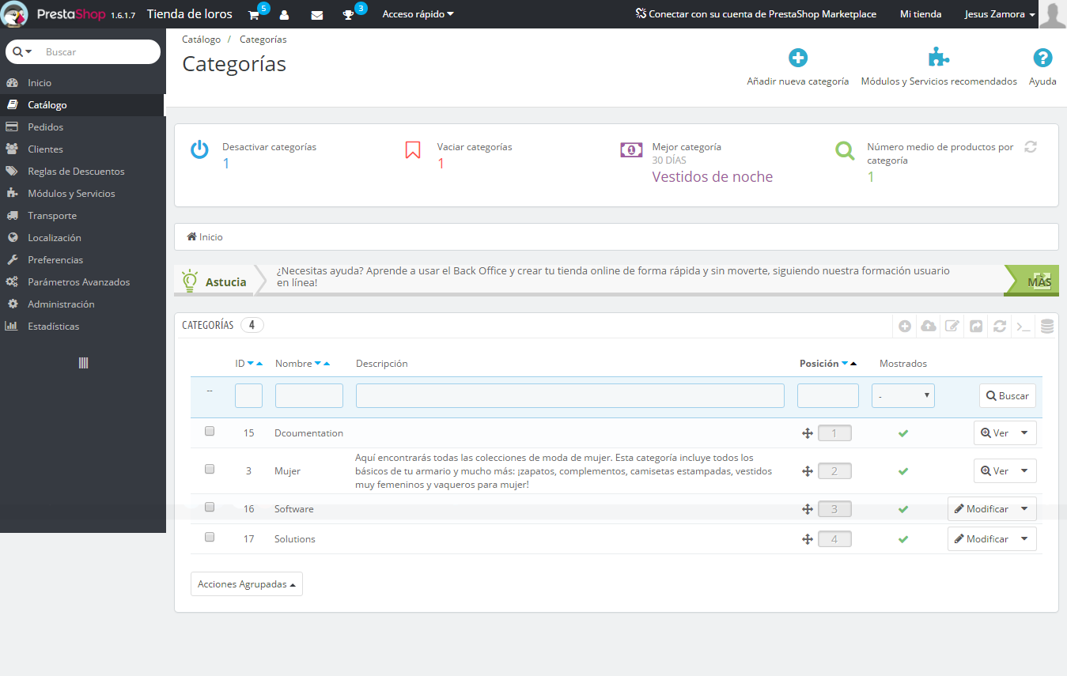

Horizontal Menu module from the top, I change the menu to set the category matches ordered in practice. To save all changes.
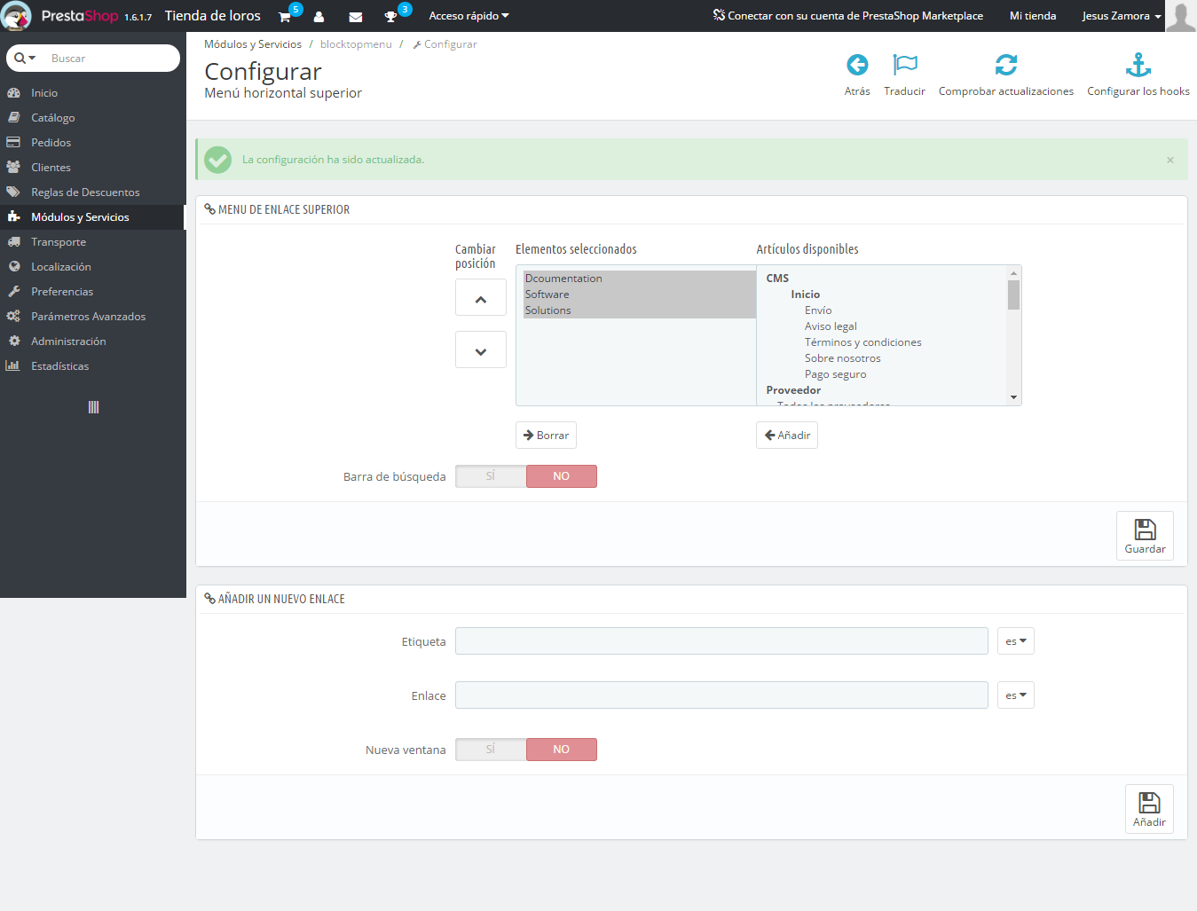

It can be seen as changes have been preserved.
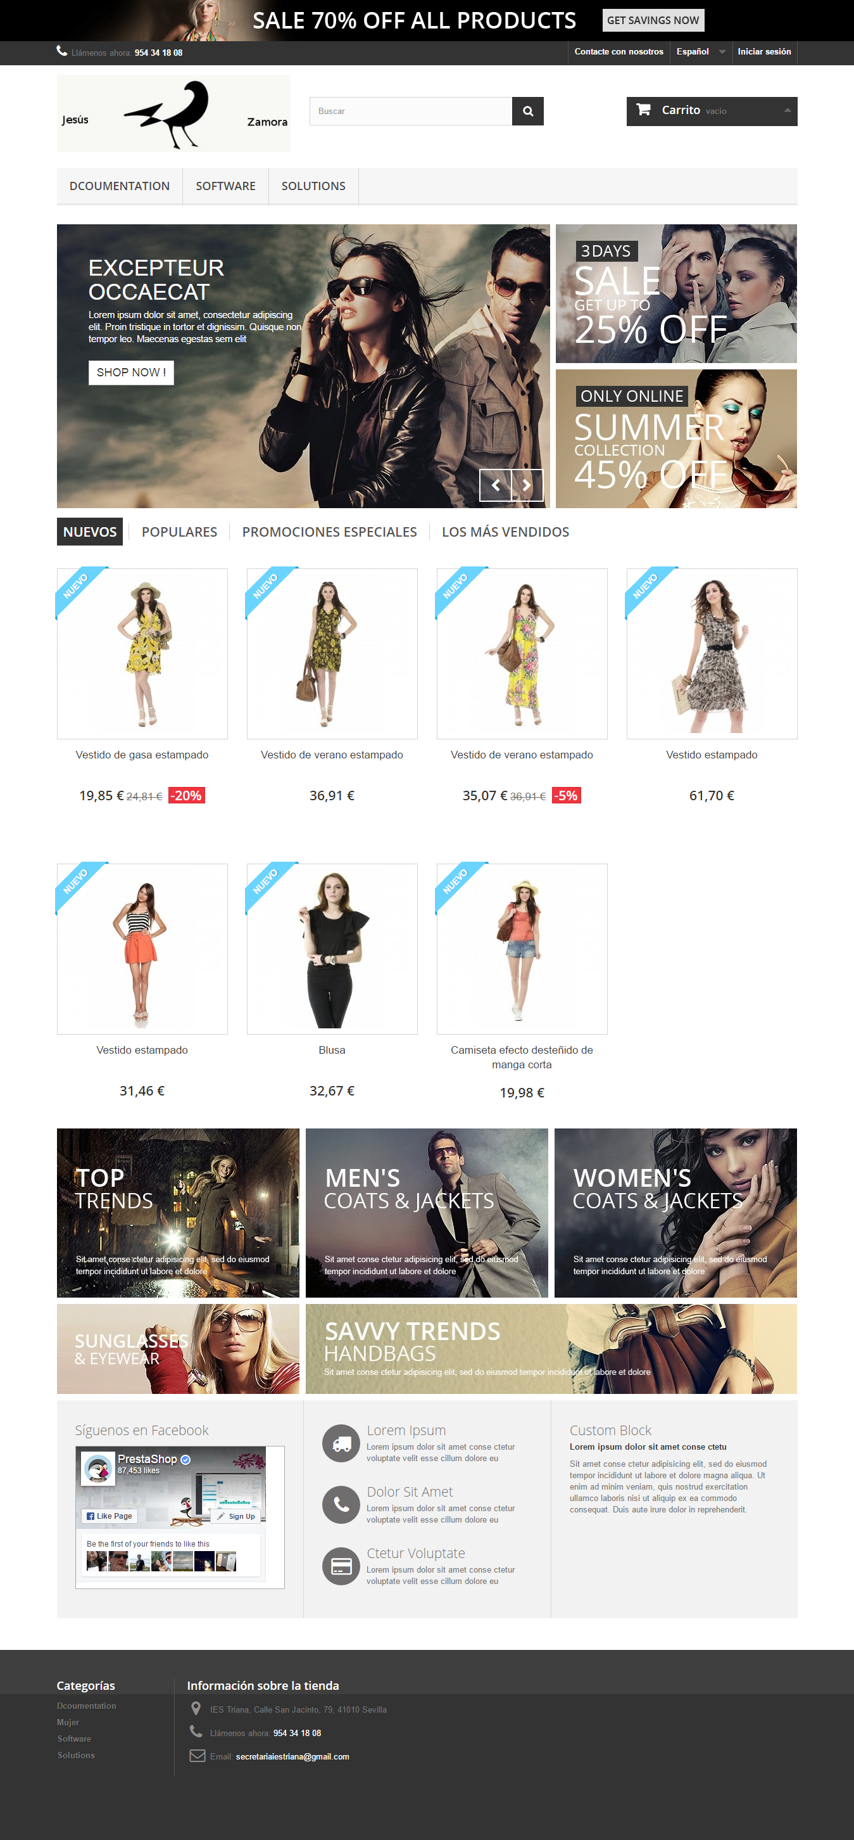
Exercise 5: Add three products for each of one the new categories and as a not logged user create a full screen snapshopt similar to the following picture (New Producs or What's new section).
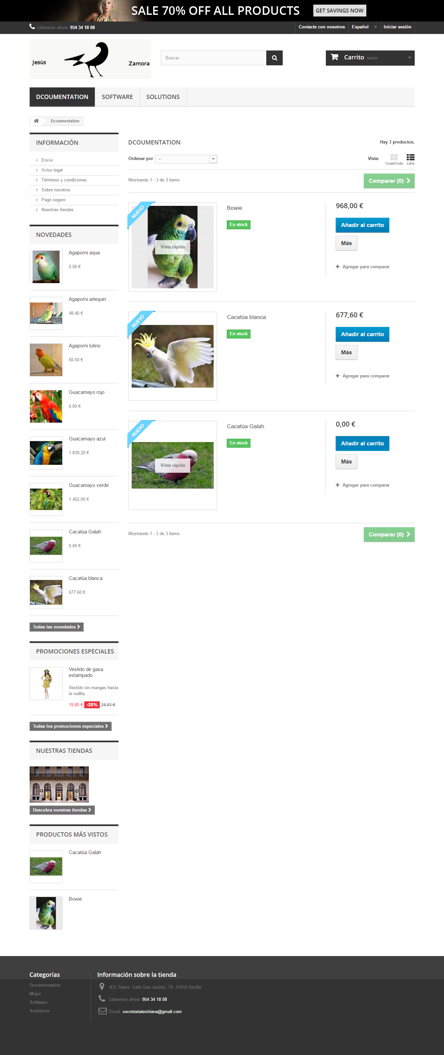

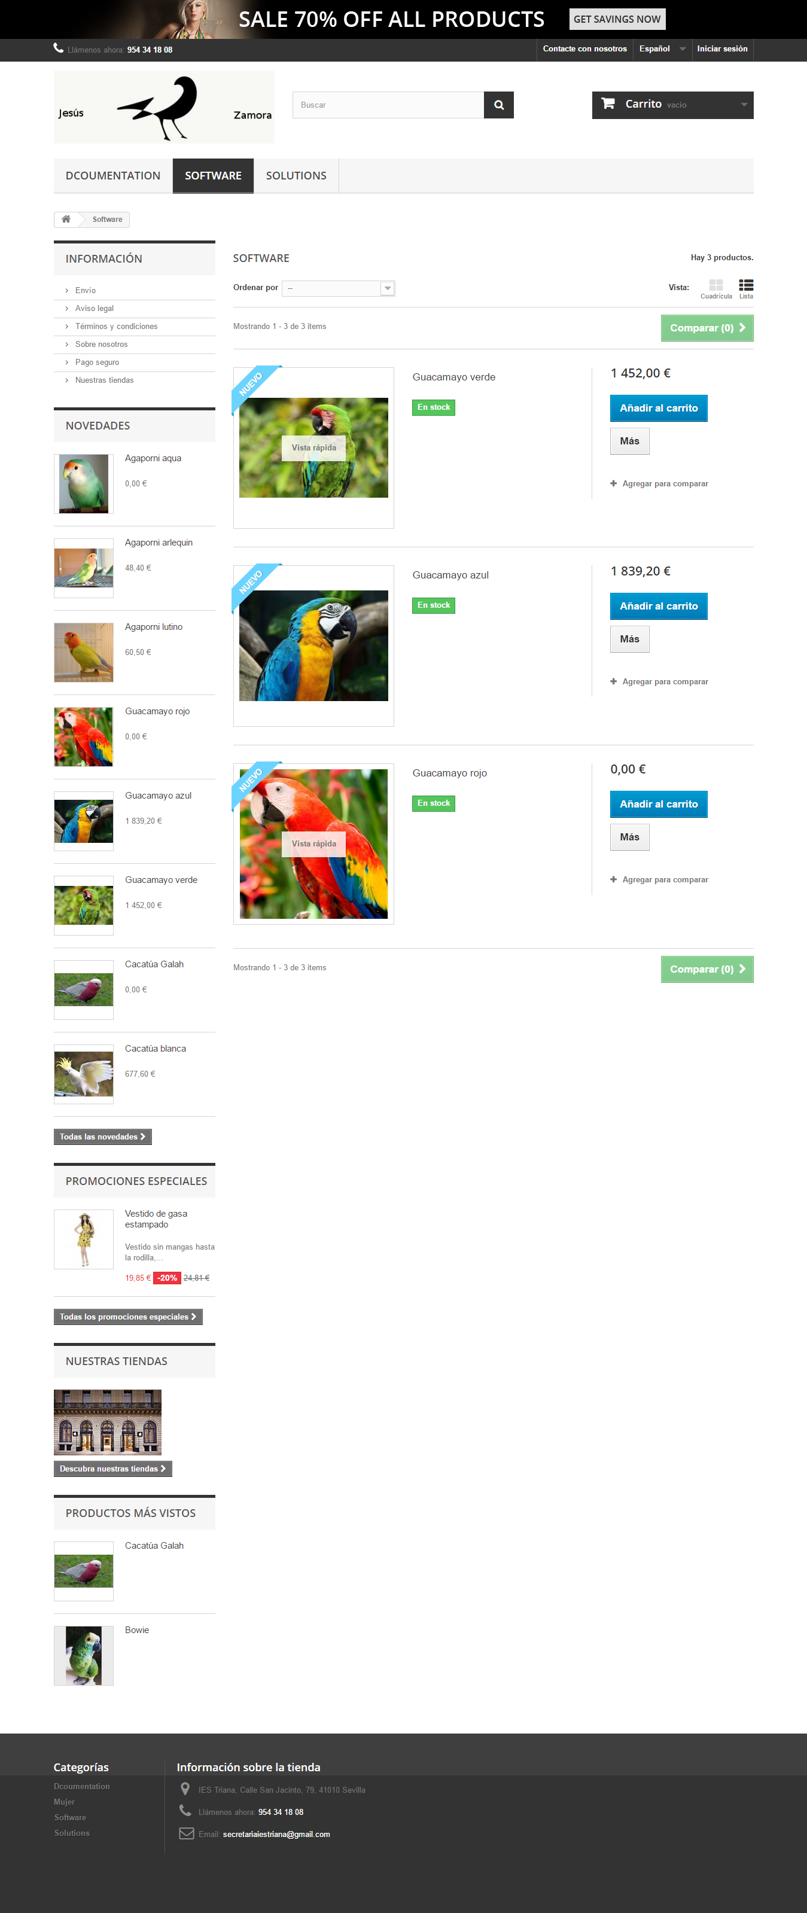

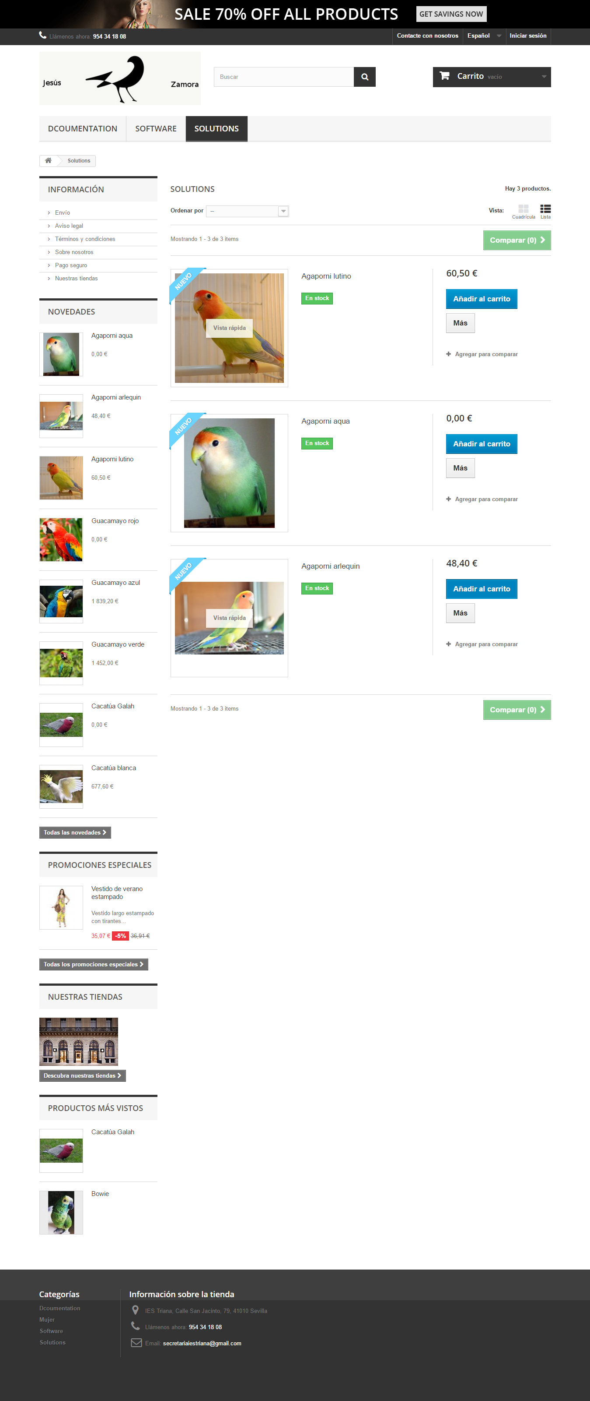
Exercise 6: Configure and Install (if needed) the Home Slide module to show the new and previously added products. Explain the process and as a not logged user create a full screen snapshopt similar to the following picture.
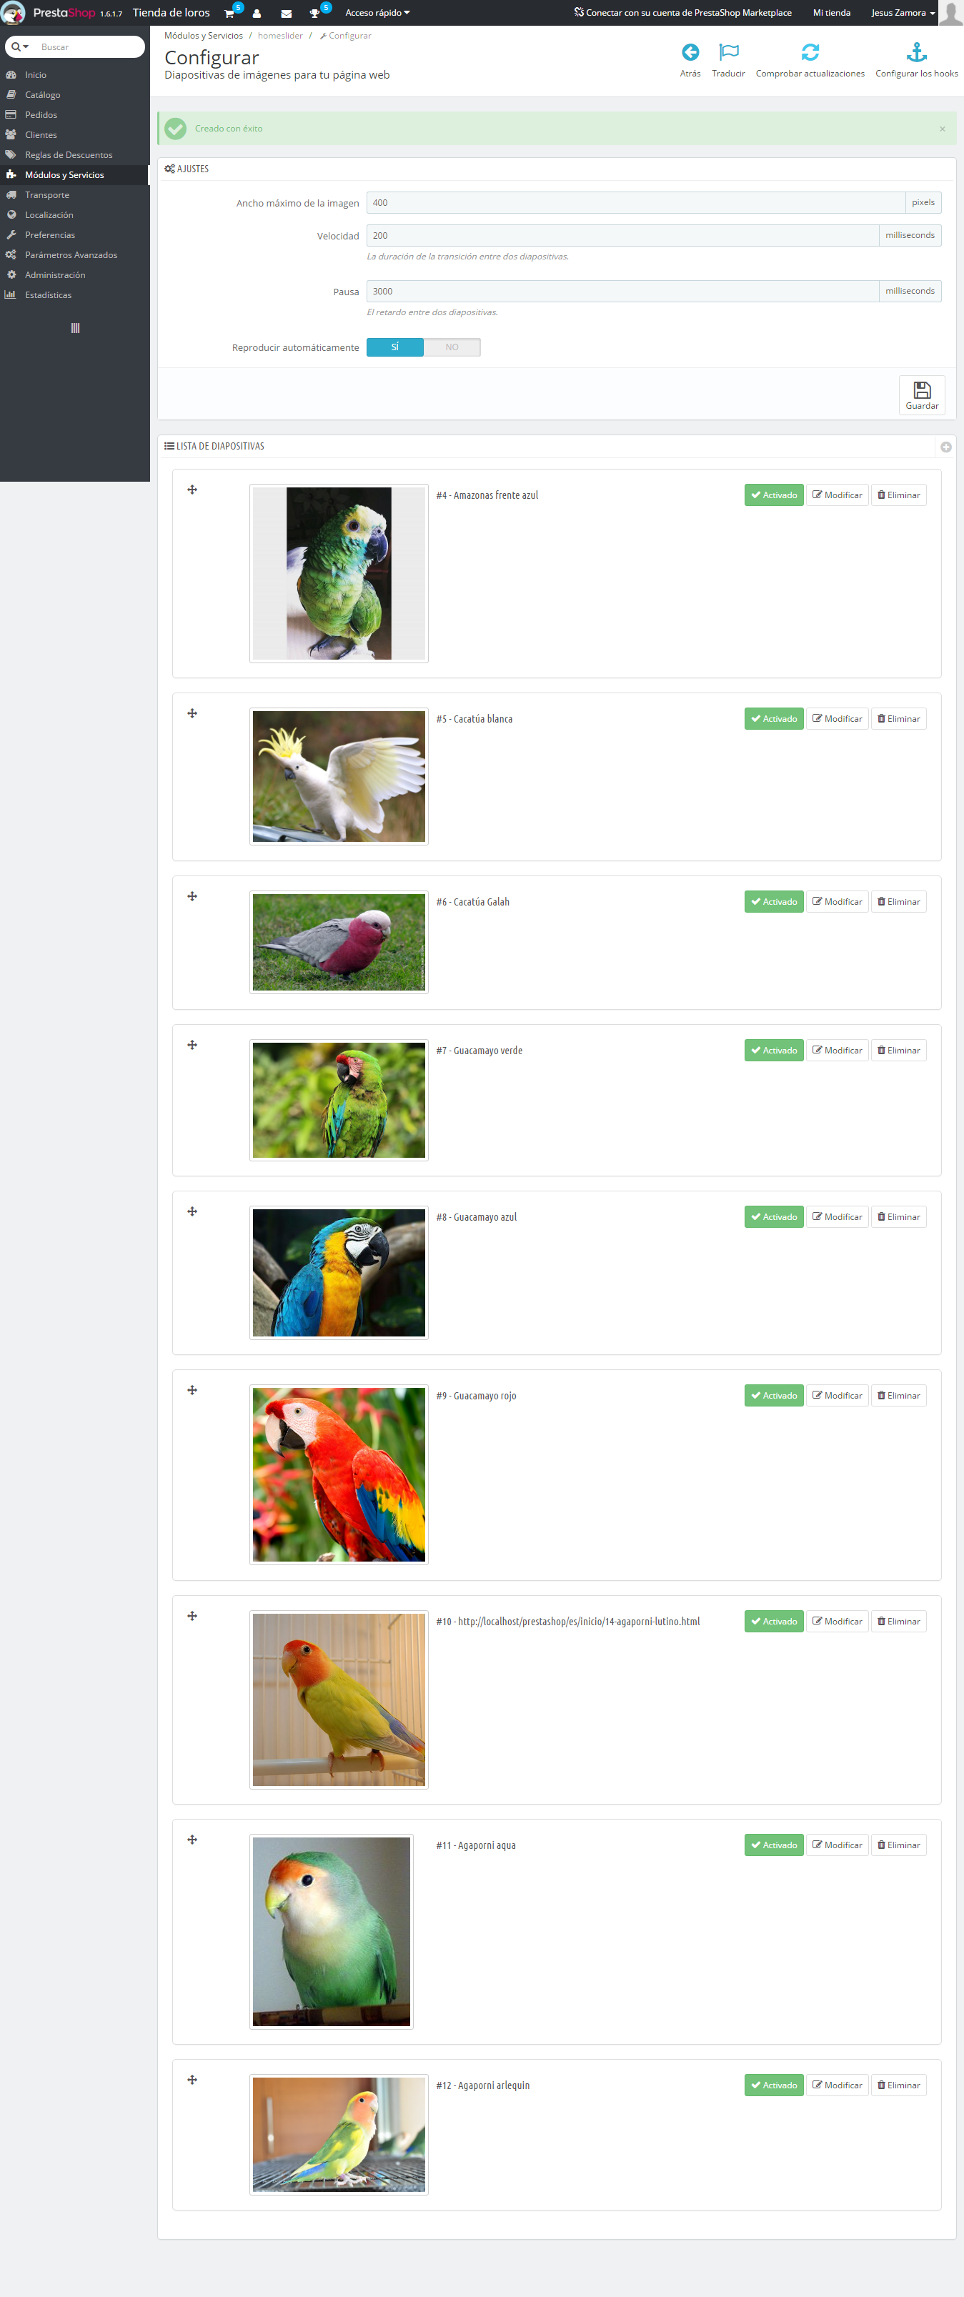

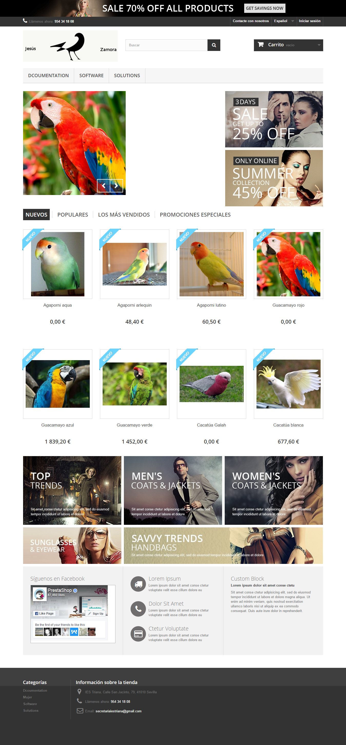

Exercise 7: Create a backUp of your app's database. firstname_lastname_prestashop.sql.

The backup of Prestashop is in the same folder of the exercise.

Exercise 8: Look for 10 things to secure Prestashop after installation.
- To do Back up.
- Set user alphanumeric keys.
- Change the path to the control panel
- Install known plugins.
- Ensure an alphanumeric key to access the database.
- Use plugins that provide security measures.
- Edit the .htaccess file allowing only users with specific profile, or IP capabilities can access files that are defined.
- Establishing different roles of users, so they do not have privileges
administrator.
- Uninstall and delete themes or plugins that are not in use.
- Limit the attempt to access the control panel.

